University of Mary Department of Education

Instructional Sequence

Grade Level: 5th Grade
Subject(s) Area: Art
Materials Needed: Watercolor paper, watercolors, paint brushes, pencils, rulers, black markers, pictures of aquarium animals and crayons (markers or colored pencils).
Standards:
- 8.1.2 Understand how different techniques are used to create visual art.
- 8.2.1 Know the effects of visual art structures and functions.
Objectives:
- Students will create an art project using one point perspective.

Learning Activities:
- Will show artwork from Filippo Brunelleschi to show how he used one point perspective.
- Define one point perspective: a type of linear perspective where one vanishing points exists and lines radiate from this point.
- Will instruct students to draw a line from one corner to the opposite corner and then repeat with the remaining two corners.
- Will have students draw the floor from the one point perspective dot. Then students will draw curved lines above the floor, followed by straight lines from the curved lines to the floor.
- Will have students trace all lines with black markers.
- Will have students add in at least five fish in their aquarium.
- Will have students color fish and then proceed to watercolor their aquarium.
- Will walk around and re-teach techniques to anyone who did not understand during the lesson.
- Will explain the clean-up process to the students (make sure you put all supplies away and wipe off your desk – your area should look exactly like it did before we started).
Assessment:
- Students will construct appropriate lines and highlighting them.
- Students will use watercolors appropriately.
- Students will orally show me their focal point and have a completed final project displaying one point perspective.
Reflection:
Revised 8/30/10

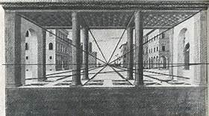

Filippo Brunelleschi was a well-known artist during the Renaissance Period.

Found at: http://www.bing.com/images/search?q=Filippo+Brunelleschi+Famous+Perspective+Sketches&FORM=IRTRRL

Aquarium fish examples

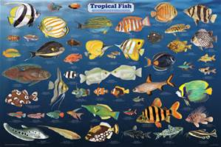

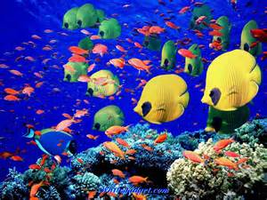
Fish pictures found at: http://www.bing.com/images/search?q=aquarium+fish+pictures+and+names&id=9EA3BFD129D038AC8F9B38E6F1E0759B2AA2AFF3&FORM=IQFRBA

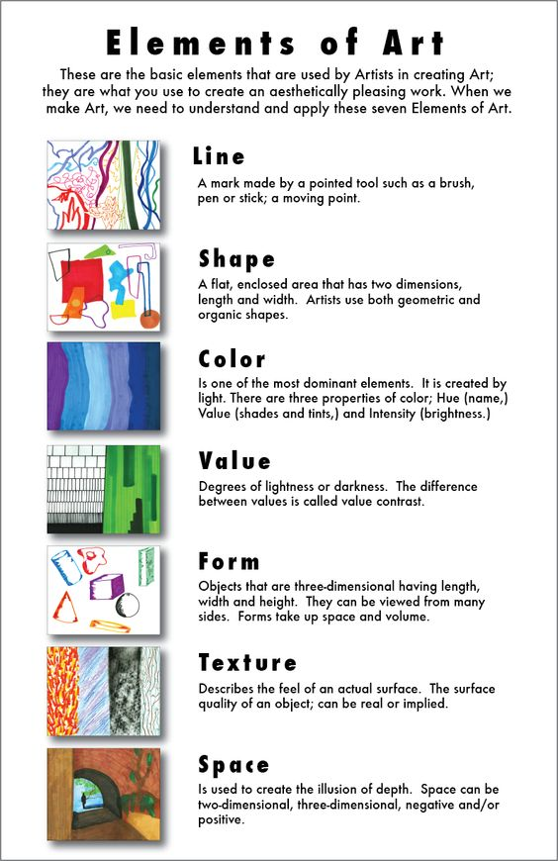

Project should look similar to this:

